**Northern Fury #43 – Red Devils**

**Playtest Report by AndrewJ Mar 2021**

**SITUATION**

The drive to liberate Norway is underway! With the Soviets starting to retreat, NATO is launching a series of amphibious and airborne attacks to sever the major lines of communication, and seize important airfields and bases along the length of the country. We've been directed to lead the attack on Banak, the northern-most base in the operation, and the one closest to Soviet-occupied Finland.

Intel's briefed us on the situation, and it's a little ominous.

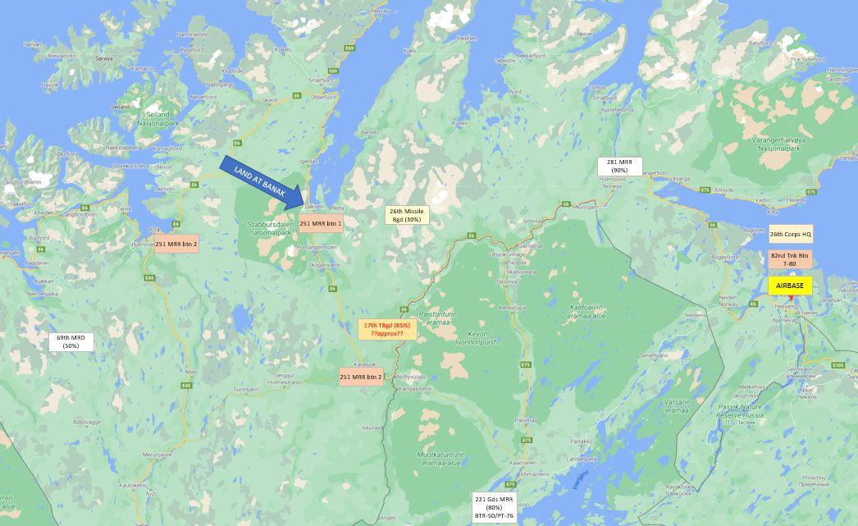

The area we're going into is mostly occupied by low-readiness units, in this case a motor-rifle regiment equipped with T-55s and BTR-152s. That might sound weak to a heavy ground force, but T-55s are quite capable of beating up on para-dropped light infantry. Apparently, there's a battalion-sized force in the vicinity of Banak itself. The other battalions are spread out on either side of us along the highway, at Alta and Karasjok. Alta will be under attack by Royal Marines, which should pin that battalion, and hopefully the one in Karasjok is far enough out that it won't make an appearance. There's also a badly battered missile brigade somewhere to our east (maybe the same ones we hit in NF41?), but I doubt it will get close enough for us to spot it.

Far more worrisome is the 17th Tank Brigade, which is mostly intact, much more dangerous than a battalion of reservists, and is location unknown! "Probably NW Finland or south of Banak" say the intel guys. That means it's pretty much on our doorstep, although we're not certain exactly where. There's also one of those over-strength tank battalions (40 x T-80s, yikes), but that's far away east of us in Kirkenes, and it would probably take a full day to march here by road. It's the 17th that scares me most.

**FORCES**

I have a variety of C-130-borne paratroopers, mostly British with some Canadians and Dutch, deployed at airfields in the northern UK and Iceland. Like paratroopers everywhere, they're not all that heavily armed. It'll be Milans and Carl Gustavs vs. the enemy armour, plus a few mortar and 105mm batteries. The heaviest support I'll have will come six hours later when I can deploy some SAMs and very light armour (Scorpions and M113s), and that's not a lot to hold off the Soviet armoured horde.

Air support will come from the Vinson and Invincible, but they're also supporting the attack on Alta by the Royal Marines, so we don't have access to their entire air-wing. We've got some F-18s, Harriers, and attack helicopters on call, but the bulk of the Vinson's power (the A-6s) is allocated to other tasks. We'll have to call in favours if we want those on our side. We don't have a lot of fighter cover either, so hopefully the Soviets haven't had time to recover from their heavy losses in the past week.

**THE PLAN**

Paratrooper boots are expected on the ground by 1800Z, which means my most distant C-130s have to start taking off in about an hour and a half, if they're going to make it in time. It's a roughly four-hour trip each way, and most of them should be able to make it home without refuelling. (The older Canadian C-130s at Reykjavik have a short range, but unfortunately can't refuel, so they will need to stop at Jan Mayen and refuel on the way home.)

Recce troops at Banak haven't reported any enemy contacts yet, but I'm not convinced nothing's there. A few MANPADS or AAA could massacre the incoming C-130s, not to mention any medium SAMs which might be lurking in the area. I desperately need reconnaissance, so I'll be launching an immediate limited strike from the carriers. My hope is to provoke the defences and CAP to react and reveal themselves, and then rush back to the carrier to reload in time for the C-130s to arrive.

After that, it's a matter of digging in and holding on as best I can. If a heavy armoured formation arrives, Banak may turn out to be an airbase too far...

**BANAK STRIKES**

Before command staff can get much further, a messenger comes hastening in with reports from the SOF recce troops hiding around Banak. They can see at least one mobile SAM unit in the centre of the area, another mobile unit of some sort, and four Hinds and four Su-25s parked in revetments on the airfield. This is definitely worth hitting, and orders are issued to start launching recce and strike aircraft from the carriers.

As my planes approach Banak we start to get ESM indications of a powerful air surveillance radar in northern Finland, so the enemy can definitely see us coming. SOF starts sending flash messages about activity on the airfield, as previously un-spotted MiG-23s start rolling out of the hangar and taxiing to take off. There's half a dozen of them, but fortunately the Sparrows on my three F-14s (two fighters and a TARPS bird) have a longer range than the Apexes on the Floggers, and we manage to engage and destroy them without loss.

The first strikers on-site are a pair of F-18s, equipped with Mavericks and FLIR pods, coming in at high altitude, above the ceiling of medium SAMs, and they report that the area is packed with enemy units. There's trucks, APCs, and infantry all over the place, plenty of heavy AAA (57mm), and what looks like a second SAM site, possibly an SA-6, east of town. The pilots open up with Mavericks, killing the central SA-8, but that causes another hidden SA-8 to open fire on the incoming missiles. The F-18s make a note of that while they stay loitering overhead, using their targeting pods to make a good list of targets, which they radio to the incoming strike.

My original intention had been to only use part of my air assets, reserving some for later, but there is so much to hit here that it is clear I can't delay. Over the course of the next hour and a half I use all my aircraft to attack Banak with a series of strikes, coming in very low through valleys and popping over ridges to hit SAMs and AAA with minimal warning. As they dash away they're pursued by SA-7s, but fortunately none of them manage to hit. The F-18s carry heavy loads and have excellent sensors, but it turns out to be the Harriers which do the bulk of the work, hustling back to their carrier, pulling a quick 15 minute reload, and returning immediately for a second attack. Even some of my attack helicopters get in on the action, operating at the extreme end of their range and cutting into their fuel reserves in order to get good hits on the closest enemy units.

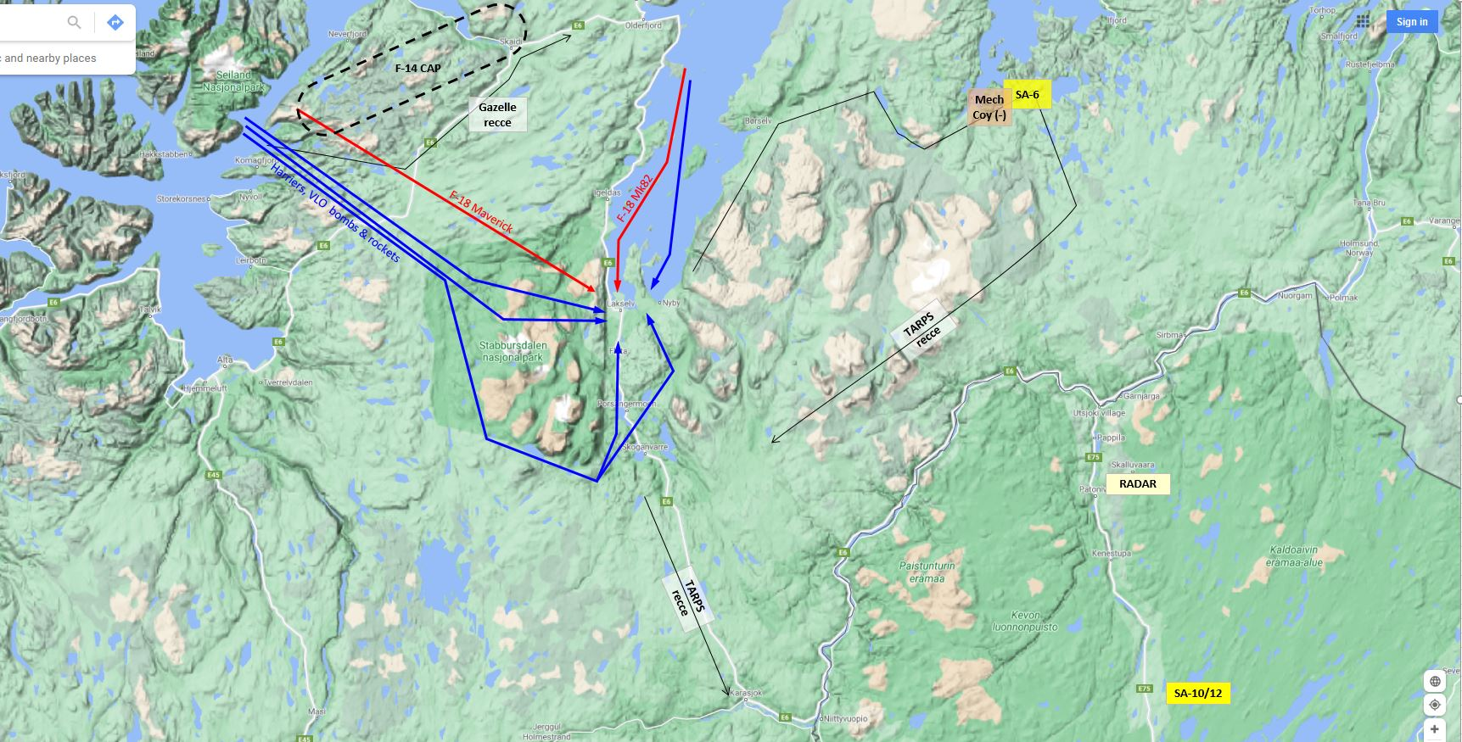

By the end of the strikes reconnaissance assets report that all the aircraft on the flight line are wrecked and in flames, and the AAA and SAM sites seem to have been crippled or eliminated. My initial Harrier strikes coming in from the south also spotted a BM-21 battery lurking about 3 miles south of the airfield, and a howitzer battery in the south end of town. Both of these high-value targets are hit and eliminated, as is a tank platoon in the centre of town, which succumbs to a well-placed cluster bomb.

**RECCE**

As the last of the strikes continue, my TARPS-equipped F-14 heads south down the E6 highway towards Karasjok, looking for enemy units. None turn up, but an SA-10/12 in northern Finland opens fire, forcing my plane to dive away into the cover of a valley. I had hoped to follow the E-6 all the way along the Finnish border, but that's clearly not going to work, so the F-14 heads up to the coast to check the roads there. An SA-6 opens fire on the plane on the coast near Kunes, and the pilot manages to get a glimpse of a small company(-) mech force of T-72s, BMP-3s, and mobile AAA near the SAM site. Nothing else seems to be there, so the pilot turns and heads back.

So far there's no sign of the 17th Tank Brigade, but that doesn't mean its not out there. If it's tucked into a valley somewhere, bivouacked under its nets, then I could quite probably have missed it. We'll have to do another recce run as soon as the assets become available.

**C-130s UP**

As the recce bird is heading home, the C-130s are taking off and heading north on their long journey to the form-up point off the North Cape. Command staff are still debating the situation at the target. Yes, the SAMs and AAA seem to be down, but it's still a hot LZ, with numerous APC and infantry units spread around. Can we handle this with the paratroopers alone, or should the commander swallow his pride and ask for the A-6s to pound the area before the landing? Or do we need to hold the A-6s to deal with the expected Soviet counter-attack? Discussion is heated, and time is short.

Where is the 17th hiding??

The attack on Banak continues...

**THE LANDING**

As the C-130s drone northwards over the cold waters of the Norwegian Sea, command staff are still debating whether or not to call in additional air support. Rather than use the A-6s, they decide to send in the last available attack helicopter, and a pair of F-18s which had been reloading for a HARM/Cluster bomb role since the start of the mission. These arrive shortly before the C-130s, and manage to engage and disrupt the enemy troops closest to the landing zones, giving us an extra measure of clearance between the landing troops and their foe. The Lynx then hurries directly home to the carrier, while the F-18s continue on to fire some HARMs at the SA-6 on the coast near Kunes.

The landing itself starts in the dusk around 1800Z, and is divided into two LZs, a large one at the north end of Banak airfield itself, and one in the fields about three miles east of Banak, near the hamlet of Nyby. (There's not actually a lot of open ground for a landing around Banak. Most of the 'flat' ground is actually scrubby forest or rocks, perfectly suited for disabling half the paratroopers with lacerations and broken bones, or is already occupied by Soviet troops.) First in are the para regiments, 1 Para taking the airfield LZ, and 2 Para taking the Nyby LZ. They manage to land without being shot at, and begin working their way towards the remaining Soviet troops, which are mostly concentrated in Lakselv, south of the airport. Milans do a great job of taking out BTR-50s, and with mortar support the paras clear out the rest of the Soviet infantry. There are multiple truck and logistical units south of Lakselv, and even a pair of large 120mm mortar units which hadn't been recognized before. Fortunately, those don't seem to be firing in all the confusion, and the area is cleared.

As Banak is being secured, additional troops, artillery batteries, and headquarters units are dropped onto the airbase. There are several large truck parks and HQs in the area, and demolition teams start working their way among them, picking out any items of intelligence interest, and using charges of C-4 to wreck the remainder. Scout cars are sent out, south along the E6 highway, and north-east along coastal road Fv98. Blowpipe gunners hurry to spread out along the high ground surrounding the region, Milan teams take up positions overlooking both main roads, and most of the infantry takes up blocking positions south of Lakselv and near Nyby. The artillery looks for positions between the two, trying to make use of the gullies in the high ground to the south to get a little cover. Meanwhile, HQ, logistic units, and the last of the infantry mill about in a confused mess in the middle. Other than the scout cars, we're not going too far afield, and hopefully that won't come back to bite us.

**RECCE**

As the Banak landing tries to sort itself out, the carrier sends out another F-14 on a TARPS reconnaissance flight, heading up the coast road at 1945Z. It confirms the SA-6 etc. are still at Kunes, and then heads down along the Karasjohka river valley on the Finnish border, over to Karasjok, and back up the E-6 to Banak. The SA-10 in Finland takes a few shots, but the pilot manages to elude them all by flying low in the river valley, and returns with the news that he's seen nothing on any of the roads leading to Banak. So far, the 17th Tank Brigade remains frustratingly elusive.

**PROBING**

With no sign of the 17th, staff decide they might as well attack the small mechanized formation up on the coast near Kunes, and some Harriers and F-18s are despatched to strike it. The aircraft are just passing Banak when our southern scout car reports a mixed company of BTR-50s and T-55s coming up the E-6 towards Banak. Two of the Harriers are diverted south, and a combination of cluster bombs, artillery, and a single Milan shot manage to wreck the force before it can get into town. Given the old equipment, this probe would have been part of the same 251st MRR which was occupying the Banak region, not the 17th.

With that complete, the planes resume their attack on Kunes, with F-18s coming in low over the hill to hit the SA-6 with Mk82s, while the Harriers use the rest of their cluster bombs on the mechanized units. Good night-vision equipment means the attacks come and go before the enemy can react, and the planes report numerous secondary explosions and fires behind them as they return to base. This gives us a bit more security from this direction.

**SCUD!**

At 2045Z, in the midst of the 251st’s probe, the nervous quiet at Banak is suddenly broken by thunderous explosions and sonic booms, as a series of six tremendous explosions rip through the airfield. Incoming Scuds! The impact points seem to be spread out from Lakselv southwards. Some buildings get flattened, and several infantry and truck units get incinerated in the blasts. Officers hurry to get stunned troops out of the area, hoping to disperse them and get them away from potentially targeted airfield infrastructure. Three more barrages happen in the next hour or so, and there's nothing my forces can do to prevent it. As the attacks continue, it looks more and more like the Scuds are being targeted at troop concentrations, rather than the airfield itself. That means we’re being watched. One enterprising sergeant finds a body in shredded Spetznaz uniform near the edge of a Scud crater, proving there was at least one observer in among us, who is now hoist on his own petard. There are almost certainly more spotters in the area, though we haven’t been able to find them yet. By the time the attacks are done, we've lost about two plane-loads worth of infantry. Fortunately, despite one very close call, none of our artillery has been hit.

At 2100Z we get an intel report from HQ, indicating the other landings in this operation seem to be going well, which is reassuring news. Hopefully they’re not getting Scudded too.

**OPENING BANAK**

The first signs of progress at Banak come shortly after the landing, when the engineers report that they've opened some of the helipads. Gazelles and Lynxes begin gradually flying in from the Invincible once they’ve had time to ready and refuel. Unfortunately, many of the Lynxes have already used their missiles, so they're arriving empty, and they won't be able to start loading up until more missiles can be flown in.

While the helicopters make their landing, C-130s from Reykjavik and C-17s and KC-135 tankers from Mildenhall, are flying in, ready to make LAPES drops of light armoured vehicles and ammunition. The C-17s have to refuel off the Norwegian coast, but that proceeds without incident, and when the engineers announce the runways are open at 0040Z, the aircraft are already approaching northern Norway, poised to begin dropping reinforcements and supplies. Ground crew immediately hurry out to grab TOW missiles for the helicopters, but it will still be several hours before the last of them are ready.

The opening of the runway also triggers the launch of Harriers from the northern Scottish airbases, ferrying up to operate out of Banak. They could have started sooner, anticipating the opening of the runways, but I had no intention of leaving them stranded at the end of their fuel range if something went wrong, and the runway was delayed.

**THE 17th ARRIVES**

Just as the Harriers arrive at Banak (0240Z), a signals officer rushes in with an urgent message. Higher level intel is reporting large enemy forces approaching Banak from the south! My own ESM intel is reporting multiple new SA-6 radars down towards Karasjok, at the bottom of the E6. This is great timing - for the enemy! My reloading helicopters are not ready yet, the new Harriers are only just landing, the planes which took out the northern mechanized force aren't ready either, and it's night, so most of my quick turnaround isn't operational.

Although I haven't spotted the ground forces yet, the timing and direction is plausible, and I have no reason to doubt this is the real thing. Both carriers are ordered to launch their remaining ready Harriers and F-18s, and the pre-planned F-18 SEAD group is ordered into the air as well. A pair of Gazelles, and my last few TOW-armed Lynxes are scrambled at Banak. I'm still holding the A-6s in reserve for now.

Do we have enough? Time will tell.

A little more time to play, therefore...

**ADVANCE OF THE 17th**

The helicopters head south along the E6 highway, staying low and hunting for enemy vehicles, but they don't find anything, at least in the first 20 miles or so. To the aircraft overhead, the situation is much different. There are multiple SAM and surveillance radars in the area, at least two SAMs radiating while moving along the road (a neat trick for SA-6s), and three more plus surveillance radars in Karasjok. The SEAD planes move in, and manage to damage and degrade the SA-6s with volleys of HARMs and Mavericks, before being chased away at low level by SA-10s fired from Finland.

The pilots can now clearly see two columns of vehicles on their FLIR, apparently one tank battalion to the west of the highway, and one mechanized battalion to the east, plus a few support units in between. Harriers and F-18s fly in low to work over the tank battalion with cluster bombs, before the F-18s switch to strafing the IFVs. With the cover of darkness, they can come in low and slow and use their night-vision to make repeated attacks on the lightly armoured BMPs, and soon the infantry are badly damaged and in disarray. As the airplanes turn and head for home the three Lynxes move in and begin stealthily picking off the stragglers with TOW missiles.

The helicopters still have a few missiles left when the attack is complete, so they go sneaking in on Karasjok, where the F-18s had spotted numerous unidentified units during their SEAD attacks. They manage to get a few of the outlying radars by staying low in the river valleys, but a few long-ranged shots by alert MANPADS gunners convince them that this is a bad idea, and the last of them slinks away as it starts growing light in the east.

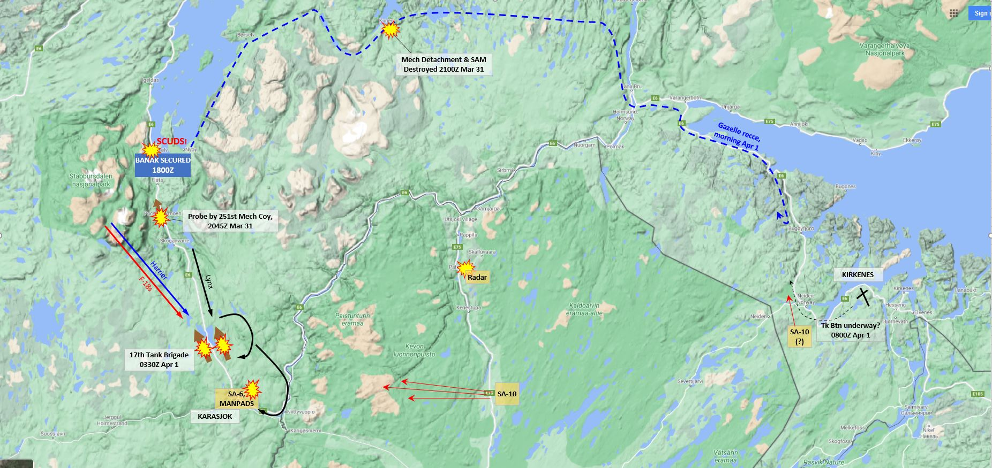

**MOVEMENT & RECCE**

One thing that's been a welcome surprise so far, is the relative absence of Pact air-power. Other than the six Floggers which took off from Banak, the Soviets haven't made an attempt to attack or interfere. F-14s were loitering over Banak during the bombardment of the 17th TB, in case planes came in from Kirkenes, but their patrols have been uneventful. They got to watch as the second flight of SEAD planes came in from the Vinson and killed the Finnish Big Bird radar with long-ranged HARM shots, but that is all.

By 0350Z the next wave of C-130s is lifting off from Mildenhall, carrying the Ghurkas north to Banak. It's a long flight, and tankers are notified in case headwinds make them need to refuel and/or land in Scotland on the way home.

In the morning light, two Gazelles are sent scouting. One heads down the E-6, looking over the ruins of the 17th, but staying well away from the little SAMS in Karasjok. Nothing seems to be moving there, so it heads back and starts scanning the hills around Banak for spotters, but with no luck. The other heads up the coastal highway, past the wrecks of the little armoured force at Kunes, and presses on to the east. It's most of the way to Kirkenes when it gets fired on by an SA-10, and ducks down into the valley to dodge the shot. There's no sign of anything on the road here either, so it turns and heads back home.

**WARNING ORDER**

At 0800Z we get another situation update. Apparently, things are not going quite as well with the other landings in the south, where the Russians are hanging on and applying pressure, so the reserves are being committed there. No reinforcements for us!

As part of the Russian move, they are apparently releasing that over-strength tank battalion from Kirkenes. Did our helicopter recce miss it somehow, or has it not left base yet? Another recce flight is ordered up to have a look. The battalion is a powerful force, but I'm not too concerned (yet). Unless it comes with heavy air cover and other support, I think we should be able to deal with it using our fully re-armed aircraft.

**ENDGAME**

The rest of the day passes uneventfully. My Gazelles cruise up and down the roads and valleys, looking for any sign of the independent tank battalion, but nothing is moving. The Ghurkas arrive, one plane at a time to dismount hastily, and are all off-loaded shortly after noon.

In the early afternoon we get another sitrep from HQ; fighting is still heavy in the south, but there is no further mention of the battalion. A TARPS run after dusk doesn't pick up anything on IR either, and the troops settle into their trenches for a good night's sleep.